Next Generation Agent
Jinxin Wei¹, Zhe Hou²
¹Vocational School of Juancheng, China, wjxabai@163.com
²No.1 High School of Juancheng, China, 1107163828@qq.com

Abstract:According to the drawbacks of large language model, I design a new agent which can overcome the drawbacks. The agent contains four deep neural networks, which is abstract network, concrete network, decision network, execution network. Each of the four networks just do one thing, so it focus what it can do just like brain works. The input is perception information by sensor. The output1 are classes and attributes(common sense), the output2 is memory or consciousness, the output3 is logic and theory, the output4 is action and practice. The No.1 and No.2 constitute an auto-encoder. The dimensions of classes are very high if the grain size is very small when one-hot encoding used, so binary encoding can be used. With the help of muti-level classes and sentence structure, output1 is produced as one sentence and common sense. With the help of one order dimension, the output3 is a sentence, so the reasoning speed is more higher than LLM. The probability of sentence is joint probability of words, so only high probability of words can produce, so the hallucination problem alleviates. The new agent has two new network to interact with the true world that is the robot really need and it produces memory, common sense, consciousness, that makes robot more like human. With the help of multi-value functions, the independent consciousness is produced. It is initiative, not rely on prompt. Causal reasoning and Continuous reasoning are realized by concatenate output3 with the input of No.3 as the new input of No.3.
Keyword: agent, large language model, deep neural network, abstract network, concrete network, decision network, execution network, class, attribute, memory, common sense, consciousness, logic, action, supervised learning, unsupervised learning, reinforcement learning, binary encoding, generation, intersection, round function, concatenate, hallucination, independent consciousness, causal reasoning, continuous reasoning
- Introduction
Nowdays there are many agents which based on LLM exist. LLM have some advantages and drawbacks. The advantages are that it contains connections and relations of words, so it have the logic of language. But the drawbacks are low generation speed, one word once a time, meanwhile LLM only have the logic of concept and symbol, it lacks connections and relations with real word and it lacks the memory of nature things. So it can’t interact with nature, then it lacks empathy and emotion with human. Secondly, LLM must have prompt to generate, it lacks the initiative. Thirdly LLM is a network which can recognize, generate text, answer question and reasoning, it dose so many tasks, this scene is different from the brain which has several parts to do different things separately. Fourthly LLM doesn't know which input is new to it, when to learn the new knowledge. Fifthly, LLM doesn’t know which question is forbidden to answer. For example, a child want to lure LLM to do role play to generate sex, violence or other criminal contents. Sixthly, LLM has hallucination problem.

- A New Architecture
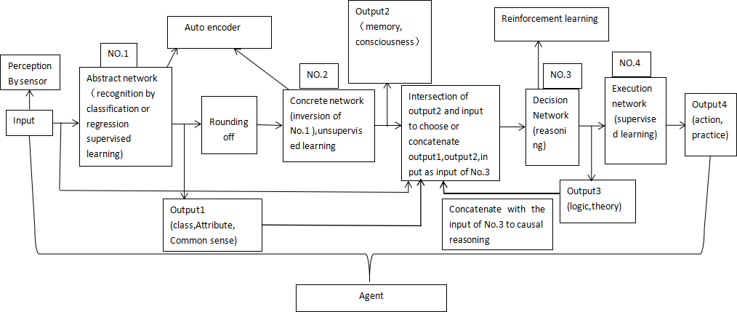
Fig 1: The Architecture of Agent

According to these drawbacks, I design a new agent which can overcome the drawbacks. The architecture is shown in figure 1. The agent contains four DNNs, which is abstract network[1], concrete network[1], decision network, execution network. The input is perception information by sensor such as vision, audio, touch, taste, smell. The output1 are classes and attributes(common sense)[2], the output2 is memory or consciousness[1], the output3 is logic and theory, the output4 is action and practice. The No.1 is trained by supervised learning, the no.2 is the inversion function of No.1[1]. We train No.1 first, then set it as untrainable, then train the No.2 by unsupervised learning[3]. The No.1 and No.2 constitute an auto-encoder. The No.3 is trained by reinforcement learning like reasoning model. The No.4 is trained by supervised learning.

Why the No.1 is designed to classify and regress? When the output1 are classes and attributes, it is easy to prevent the particular class which is the forbidden class such as sex, violence and crime to generate contents by No.2. It is better to set output4 as rejection to action directly. Can some class have the information to generate content? The answer is yes, but you need some trick methods. Firstly, the classes are divided into input types such as language, vision, audio, touch, taste, smell[2]. Secondly, the classes are divided into multi-value functions or without aim or intention. Thirdly, the classes are divided into declarative sentence, exclamatory sentence, imperative sentence and interrogative sentence[2]. Fourthly, the classes are divided into Subject, predicate, object, predicative, attributive, adverbial, complement, appositive[2]. Subject such as science, engineering, human, animal, plants, products and so on can be divided into the fine-grained[2]. For example, the science can divide into math, then geometry, then the Pythagorean theorem. Another example, the animal can divide into mammal, then dog, then breeds. The grain size is not the smaller the better. The breed can set as 10 familiar breeds, others can set as the eleventh breed. For example, attributive is divided into amount, color, shape, size, location, material, texture, style, expression and so on[2]. The color can then divided into 16 familiar class and some gradient. With the sentence elements, we can make the classes into a long sentence. The advantage of this method is that the information of input can be detailed and the generation can be detailed. It is better than attention method, because the attention method may miss some details. With the help of computer, the agent can get the detail information, or it will miss with attention method if the Information is written in water. With the detail, the decision can be made more accuracy by No.3. But it have disadvantages, the dimensions of classes are very high if the grain size is very small when one-hot encoding used, so binary encoding can be used[4]. Another disadvantage is the label need huge work, lots of time and money need to invest. Through roughly estimate, the classes are 1 billion if the grain size is small and ten million if the grain size is medium. The binary encoding makes the amount of dimensions lower that is 30 if the grain size is small and 24 if the grain size is medium. The training method which treats classification as regression use mse[5] as the loss function[2] that is different from the one-hot encoding which use cross-entropy[6] as the loss function. The output speed is high with binary encoding, because one sentence once a time. But how to control the order of element of sentence precisely? Another method is adding one order dimension in the label, that is to say to predict the order of element of sentence. The following is the detail. First, add one dimension at the last of each element of sentence. Second, add one dimension at the last of each word in one element of sentence. This dimension is the order of sentence element and word, which means the index of word, divide the length of sentence element(the word is belonged) minus one, that is range form 0 to 1 and the index of sentence element, divide the sum of number of sentence elements minus one, that is range form 0 to 1 too. One sentence can be produced precisely by sort the words and sentence elements by the order dimension. It is two layered sort which can overcome long sentence. This method needs less classes and attributes, just to produce the words in one element of sentence, so less dimensions. This method is better for No.3 network, however the first method is better for No.1 network. Because the output3 is a sentence which like human behaves, not a word that LLM generates，the context is some sentences, so it is more comprehensive than constrained which LLM behaves. The probability of sentence is joint probability of words, so only high probability of words can produce, so the hallucination problem alleviates.

The output1 is rounded off to get standard classification result then input to No.2 to generate the input which belongs to some standard class. No.2 is mapping class to input, the process is like retrieving memory, So the output2 is memory. Because the memory is always one representative information of some classes, so round function is needed to add between No.1 and No.2. The No.2 use mse as loss function to generate the input[1]. Because Consciousness is the brain's reflection of matter, it is the look of input in the brain, so output2 can be seen as consciousness.

After output2 is generated, intersection of output2 and input is added. If the intersection is smaller than 5 percent of output2, it is better to learn the input(exclude the forbidden input), that is label the class of input and generate the input of that class. When learn, the student(small network that is less classes and attributes) can ask the teacher(large network that is large amount of classes and attributes) for the answer. If the intersection is bigger than 95 percent of output2, it is better to set concatenation of input and ouput1 as the input of No.3. If the intersection is between 5 percent and 95 percent of output2, it is better to concatenate output2 and output1 and input as the input to No.3.

No.3 is reasoning model. With the input and output2 and output1 as input, logic can be produced. It is initiative, not rely on prompt. The logic can be seen as theory. No.4 is a common DNN, it is mapping logic to action, like theory to practice. Consciousness is produced by No.2 network, but how to produce independent consciousness? Independent consciousness is always about aim or intention of robot itself. Because the aims or intentions are different, so the value functions of No.3 network are different accordingly. So more value functions are needed not only one. For example, when playing game, sometimes we want to get high score(highest score), sometimes we want to finish the game as soon as possible(shortest time), sometimes we want to play the game as long as possible(longest time), sometimes we want to finish the game with no loss(least loss), sometimes we want to play the game with fulfillment(greatest satisfaction). The aim or intention changes, the action(theory) which produced by No.3 network changes accordingly. So No.3 network can split into several small networks which trained by different value functions. It is shown in figure 2.
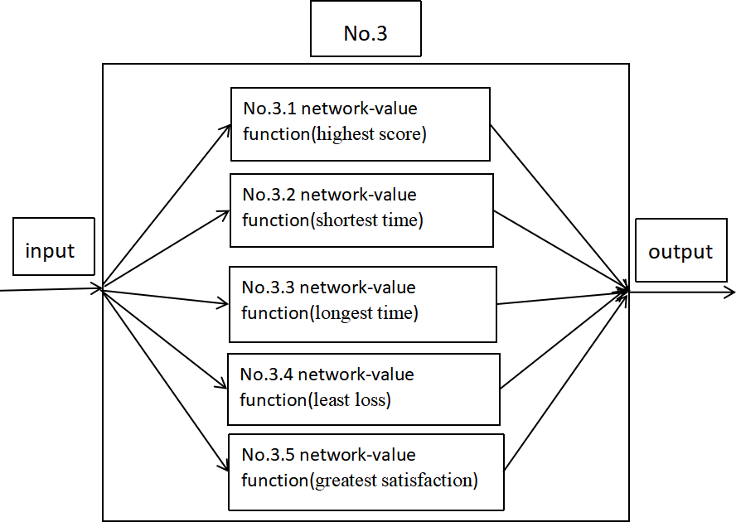
Fig 2:The inner structure of No.3 network

When No.1 network can classify the aim or intention, then one of four value function is selected definitely. For example, the input is a game scene and one mission(finish the game as soon as possible), the input is classified as shortest time class, so the according value function(No.3.2) is selected. When No.1 network can’t classify the aim or intention, for example the input is a game scene and no more information, this time we need one aim or intention from environment or the robot itself. For example the robot get input from human about finishing the game as soon as possible or the robot choose the value function itself(it has the independent consciousness). The learning process is initially the aim or intention is produced by the environment, then it is produced by the robot itself. The detail is the following. Firstly, the robot choose the value function randomly, that is the value functions have the equal probability weight, then it choose the action randomly. The probability weight of value function is increased when the environment give the positive feedback, it is decreased when the environment give negative feedback. When the robot interactive with the environment as long as possible, the independent consciousness is produced. The learning process is finished when the robot can mapping the input into the right action by itself that is most of the feedback from environment are positive feedback, for example more than 80 percent.

Causal reasoning is realized by concatenate output3 with the input of No.3 as the new input of No.3. For example, the robot see an glass cup on the desk, it is a initial scene. Then the output3 is pushing it down when low probability value function is selected, while the output3 is always pick it up with high probability value function selected. The new scene of input is the glass cup is broken, the initial scene concatenates with the new scene( the two scenes make context) and the action pushing it down as the input of No.3, the new output3 is the logic of casual reasoning. Continuous reasoning is also realized by concatenate output3 with the input of No.3 as the new input of No.3.
- Thinking

In Autonomous driving filed, the perception is directly mapping to actions. Why we add two networks? Because the high level robot confronts more complex environment than simple road situation, so two more network added. The new agent have two new networks to interact with the true world that is the robot really need. It produces common sense, memory, and consciousness, that makes robot more like human. Each of the four networks just do one thing, so it focus what it can do just like brain works. Because the huge label work and the huge computing power are needed, I can’t test it by myself, so only theory is here. How dose the whole network do? For example, when the robot see an apple on the desk by camera, it is firstly classify to vision, then subclass declarative sentence, then subclass subject is plant, then fruit, then apple. Copula is is, predicative is on the desk. A sentence is produced. It is part of output1. With apple class and its upper class’s attributes and on the desk class and its upper class’s attributes we know the apple is fruit(the upper level class), it can eat, can make many food and more information about apple(fruit’s attributes or plant’s attributes)[2]. The order of output1 is from low level class to upper level class, the more upper level the more abstract and generality, first the sentence, then the common sense, it is liking object inheritance in object-oriented programming. So common sense is part of the output1, the aim or intention of vision input is none. We also know desk is a matter to put something on by its upper class’s attributes. Meanwhile, the robot may receive the audio information( I am hungry) said by another people. It is processed similarly as vision, the aim or intention of audio input is greatest satisfaction(No.3.5). The network No.2 generates memory from the sentence. With the vision and audio information, the robot make decision by network No.3. The output3 is that pick up the apple, then wash it, then give it to the man. If only vision information, the robot can select the value function by experience by itself. The network No.4 is mapping theory to practice, that is the rotation of motor then the pose control and the path selection of the robot.
- Conclusion

4.1 In order to overcome the drawbacks LLM has, a new agent is proposed. The agent contains four DNNs, which is abstract network, concrete network, decision network, execution network. Each of the four networks just do one thing, so it focus what it can do just like brain works.

4.2 The new agent has two new networks to interact with the true world that is the robot really need. It produces common sense, memory, and consciousness, that makes robot more like human.

4.3 With the help of muti-level classes and sentence structure, output1 is produced as one sentence and common sense. With the help of one order dimension, the output3 is a sentence, so the reasoning speed is more higher than LLM. The output3 is a sentence which like human behaves, not a word that LLM generates，the context is some sentences, so it is more comprehensive than constrained which LLM behaves. The probability of sentence is joint probability of words, so only high probability of words can produce, so the hallucination problem alleviates.

4.4 With the help of multi-value functions, the independent consciousness is produced. It is initiative, not rely on prompt.
4.5 Causal reasoning and Continuous reasoning are realized by concatenate output3 with the input of No.3 as the new input of No.3.

References

[1].Jinxin Wei, Qunying Ren, A Functionally Separate Autoencoder, Future Technologies Conference (2020)

[2].Jinxin Wei, Qunying Ren, Multi-attribute Recognition, the Key to Universal Neural Network, Future Technologies Conference (2020)

[3]Ian Goodfellow, Yoshua Bengio, Aaron Courville, “Deep Learning”, MIT Press, 2016.

[4].Jinxin Wei, Zhe Hou, Binary-encoding for Label, TechRxiv, 2022

[5]Tensorflow Tutorials and Apis, 2021/12, https://tensorflow.google.cn/learn last accessed.

[6]Aurélien Géron, ”Hands-On Machine Learning with Scikit-Learn and TensorFlow”, O'Reilly Media, 2017.

